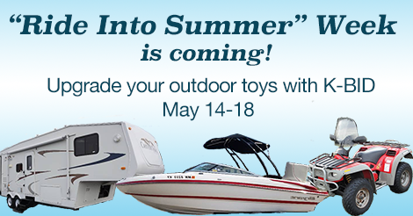  Looking to sell your summer toys?  MAY 7TH -12TH IS “RIDE INTO SUMMER” WEEK!  K-BID.com is hosting the first annual “Ride into Summer” event during the week of May 7th – 12th. This week will be promoting online auctions with Summer toys (Campers, ATV’s, Golf Carts, Motorcycles, Boats) and will be a great opportunity to sell right before the Summer season.  Don’t miss out, this event will be promoted to thousands of local buyers! Our auction process is simple:  - Bring in your assets and the appropriate paperwork to our consignment location.  - After signing a consignment contract, we take pictures and describe your items in our online auction ending the week of May 7th - 12th.  - Sellers are paid within 2 weeks of the auction closing! | Now is the time to buy and sell!  ────  Campers, ATV’s, Golf Carts, Motorcycles and More.  ────  K-BID.com has thousands of buyers!  ────  Take the hassle out of selling this Spring.  ────  Get your consignments in now!  Affiliate NAme  Street Address  City, ST ZIP Code  Telephone  Web Address  Dates and Times

