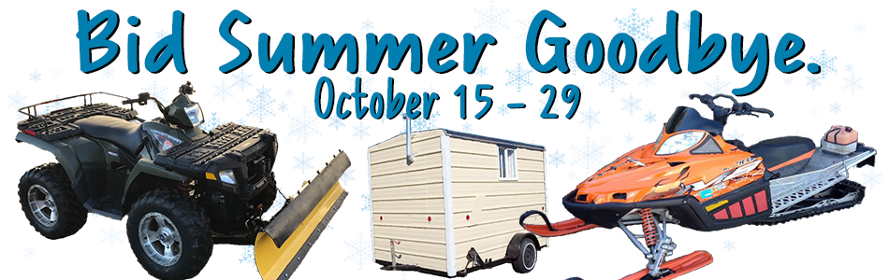
We’re ready to help you

October 15th-29th K-BID.com is hosting their first annual “Bid Summer Goodbye” event. They will be promoting online auctions for fall and winter toys and equipment including snowmobiles, ATVs, 4WD vehicles, fish houses, snow removal equipment, campers and more.
Get cash for your
Snowmobiles
Fish houses
ATVs
Plows
4WD vehicles
_____

Reach thousands
of local buyers!
_____

CALL TODAY!

Don’t miss a great opportunity to get the most cash for your stuff. These assets are at peak demand and this event will be promoted to thousands of local buyers!

The auction process is simple:
- Bring your assets and the appropriate paperwork to our location and complete a consignment contract.
- We take pictures and describe your items in our online auction closing October 15-29th.
AFFILIATE NAME
Phone
Website

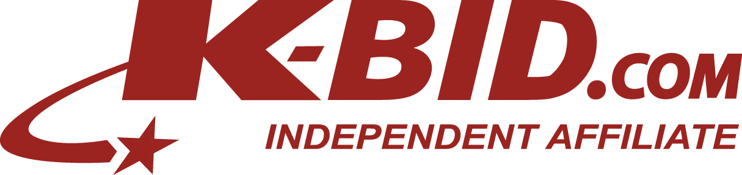
- You get paid within two weeks of the auction closing date.

Now Accepting Consignments at:
[address]
[dates and times]

