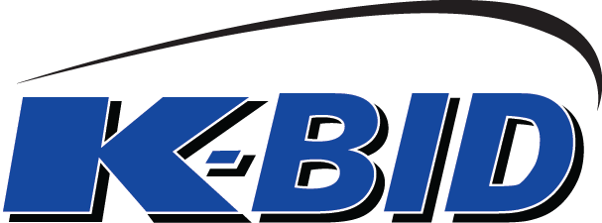

Oct. 30th 2015

A2C Online Auctions

RE: Gene A. Ellingsen Final Estate Liquidation Closing 10/19/2015

Matt/Mike,

Thanks you for the opportunity to provide marketing assistance on the above auction. I would like recap some of the highlights of our marketing efforts that made this auction a success.

Marketing Recap

This auction was one of the most trafficked auctions on K-BID.com in 2015 with 94,021 page views and saw a total of 402 distinct bidders place 5673 bids. An additional 964 bidders showed interest in this auction by adding it to their watch list on the bidder dashboard. Naturally, a large majority of bidders participating on this auction were located in the Upper Midwest. As you can see by the map of bidders below, we were also able to extend our reach to a national audience due to our marketing efforts.

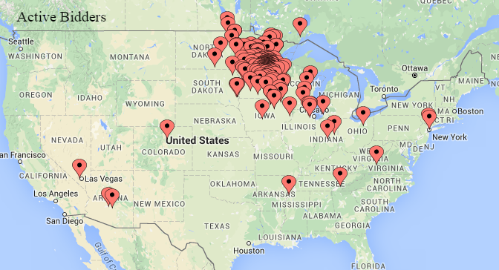



Facebook Promoted Posts
Targeted Audience: Multiple campaigns targeting people with an interest in collector vehicles, current bidders of K-BID, and people living within 25 miles of the auction location.
Location: Nationwide & within 25 miles of the auction location.
Total Reach: 367,244
Clicks Through: 21,378
CPC: $.14
Bidders Created: 93 Bidders created as a direct result of these ads.
Post Engagement: 941 Likes / 359 Shares / 124 Comments

Notes: These campaigns were incredibly effective and allowed us to reach a targeted audience at a very reasonable costs. The engagement with the ads (3 total) allows users to share the information with people that would most likely to have an interest in the auction (Collector Vehicles). You can see by the engagement numbers above that the social aspect of these campaigns was incredibly effective with 359 shares. The local audience was targeted as a convenience factor (easier pickup) has a tendency to drive bid prices higher.

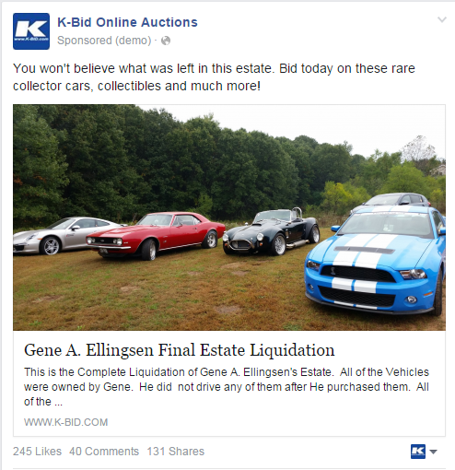

K-BID Bidder Email Blast
Targeted Audience: Multiple emails sent to registered bidders on K-BID.com who have opted in to receive promo emails. Also sent reminder email to all participating bidders on the day of closing.
Location: Throughout US
Recipients: 54,222
Opened Emails: 11,977 Unique (22.1%)
Click Through: 4,631 Unique (9%)

Notes: This email blast combined with a promotional banner on the front page allowed us to target the bidders that are current customers and all subsequent web traffic. These bidders play a crucial part in the auction as they tend to add value to the everyday items and are very active buyers. During the 2+ weeks that this auction was promoted on the front page, K-BID.com received nearly 400,000 online sessions.

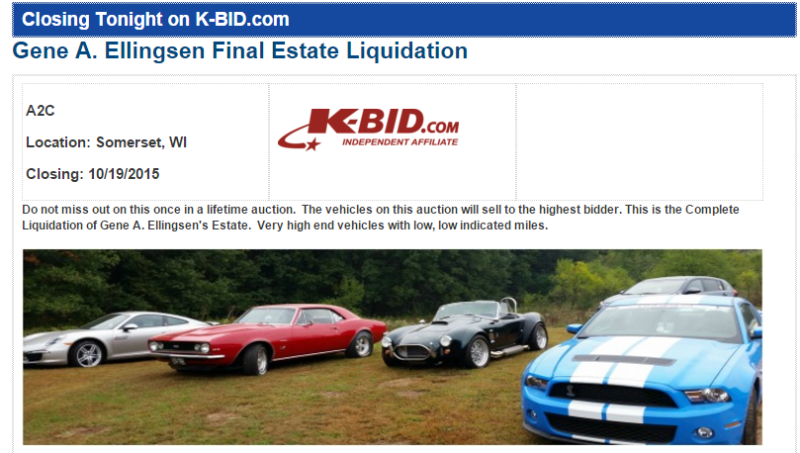

In Closing

The traffic and numbers from this auction were outstanding. We correctly assumed that the social aspect of Facebook and social media would allow this type of auction to reach a very wide audience of people. We applaud the fact that the reserves were lowered prior to the close of the auction and believe that had a definite impact on bidder engagement and the overall result of the auction. The results from these campaigns lead me to believe that the budget was correctly allocated and certainly assisted in the success of the auction.

We appreciate the opportunity to assist with this auction. Please reach out if you have any questions.

Sincerely,

Chris Schwartz
Marketing Director
K-BID Online, Inc.

