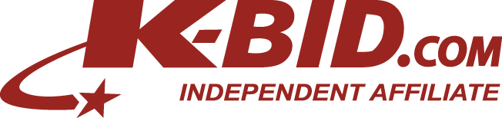
[Your Name]
[Street Address]
[City, St Zip]
[Optional – Email Address]

[Today’s Date]

[Name of Recipient]
[Title]
[Company]
[Address]
[City, St Zip]

Dear [Name of Recipient],

This might be the first letter you receive that requests opportunity to pay you – instead of the other way around. Let me explain: as an online auction company, {Affiliate Name} specializes in turning excess inventory, equipment and vehicles into cash through a competitive online auction process.

A number of our current clients were in the same position as {Company Name} and were looking for an effective way to liquidate assets. Many found themselves paying employees to list assets, had items piling up in the corner of the warehouse or ended up taking pennies on the dollar just to get rid of the problem. Our online auction process allows us to efficiently and effectively market your assets to tens of thousands of active buyers each day in order to achieve a higher return – all with a great deal of flexibility that meets our client’s needs.

As an independent affiliate of K-BID.com, {Affiliate Name} has the experience, knowledge and marketplace to help solve this problem for companies like yours. I would greatly appreciate the opportunity to discuss how our services could benefit {Company Name}. Reach me anytime at xxx-xxx-xxxx or email me at Email@Email.com.

Sincerely,

(Sign here for letters sent by mail or fax)

[Typed Name]

P.S. I have included a number of resources in this packet which further explain our auction process and some reasons why we are the preferred auction venue for hundreds of local companies.

