This is a sample document (has not been approved by state) – if used, affiliate should customize using the specifics of their COVID-19 Plan

[Affiliate Logo or Name]
COVID-19 Preparedness Plan
The health and safety of [Affiliate name] employees and customers are our foremost concern. During this pandemic it is essential for every individual involved in the auction process to comply with the following business practices to ensure their own safety, as well as the safety of others.
Auction Employees
- Employees should not come to work if they have a fever, cough, flu-like symptoms, shortness of breath, or reason to believe they have been exposed to the COVID-19 virus.
- Upon entry and exit of auction location, all are advised to use the hand sanitizer provided.
- Employees must maintain a 6-foot distance from each other whenever possible.
- Personal protective equipment must be worn (face masks and gloves) whenever employees have face-to-face contact with customers.
- Employees should wash their hands (or hand sanitizer) often with soap and water (for at least 20 seconds) often throughout the day.
- Cover coughs and sneezes with a tissue, or the inside of your elbow.
■ Tissues should be disposed of in the trash
■ Immediately wash your hands or use hand sanitizer
- Cleaning and disinfecting
■ Frequently touched surfaces multiple times per day
● This could include but is not limited to tables, doorknobs, light switches, countertops, handles, desks, phones, keyboards, toilets, faucets, and sinks.
■ If surfaces are dirty, first clean them with soap and water.
■ Then, use an EPA approved disinfectant (https://www.epa.gov/pesticide-registration/list-n-disinfectants-use-against-sa rs-cov-2)

Inspections & Removals
- COVID-19 Safe Practices signs will be posted at customer contact points.
- Customer contact points will be cleaned and disinfected with and EPA approved disinfectant (https://www.epa.gov/pesticide-registration/list-n-disinfectants-use-against-sa rs-cov-2) prior to scheduled inspection and removal times and frequently throughout the specified times. This includes tables, doorknobs, light switches, countertops, handles, desks, phones, keyboards, toilets, faucets, and sinks.
- Inspections and removals will be by appointment, using the scheduling feature within the K-BID.com website. This will limit the number of people in attendance at any one time.https://k-bid.zendesk.com/hc/en-us/articles/360045411933-Requiring-Removal-By-Appointment-
- Efforts will be made to use virtual previews, through video recording tools, whenever possible. Additional lot photos will be used to reduce the need for onsite inspection.

Prospecting Guidelines
- Sellers are encouraged to send photos and/or conduct video calls showing the assets they potentially want to consign to limit face to face contact between auctioneer and seller.
- If remote previews are not possible, one on one meetings will be limited and physical distancing guidelines will be followed, and personal protective equipment will be worn.

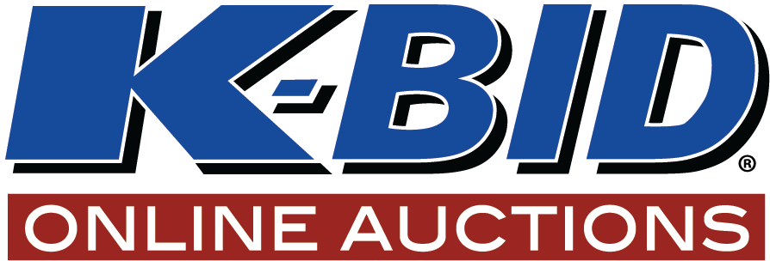
COVID-19 SAFE PRACTICE
1. Comply with local, state and federal guidelines and executive orders related to the COVID-19 virus, social distancing and isolation orders (e.g., “shelter in place” or “stay at home” orders).
2. If you are nauseous, sick, not feeling well, or have a cough, fever or runny nose, or any other symptoms of the COVID19 virus, do not enter the building.
3. Only 10 people (including crew) are allowed in the building at any one time.
4. Always allow at least 6 feet of space from others at all times.
5. Use available gloves, face masks, and hand sanitizer.
6. Wash hands often, using hot water and soap.
7. Properly dispose of tissues, gloves, and garbage.
8. Be patient and kind; everyone is doing the best they can.

