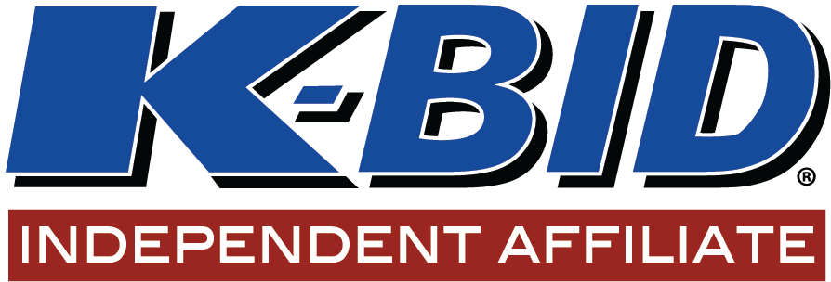

CONSIGNMENT AGREEMENT

Terms: Seller pays a per item commission rate of: _____________ with an item minimum fee of_________

Consigner Name:
Consigner Address:
Consigner Phone Number:
Date Consigned:
Items: ______________________________________________________
____________________________________________________________ ___________________________________________________________
Issues/defects_______________________________________________________________________________________________________________

I have agreed that these items are being sold without reserve and that I WILL NOT bid on my own items. I attest that I am the rightful owner of the consigned items and have the authority to sell them at Auction. I further agree that in the event that I become the high bidder on any of my own items, I will pay the full invoiced amount, AS WELL AS the commission rate of 30% with a $25 lot fee for each of those items. I understand that Auction proceeds are generally distributed ____ days following the sale of the items. A Buyers premium will be charged and collected on behalf of the auction venue, K-BID.com. K-BID.com is acting as a venue only and is not a party to this agreement. Items consigned within this agreement are scheduled to be sold at auction, should an item listed be removed/sold/pulled outside of the auction process, the seller will be charged the full commission rate plus a ____ penalty.

Consigner’s Signature: _____________________________________________________________________

Signature of Affiliate: _______________________________________________________________________

Suggested Contract Language
Affiliates may use the following language as a starting point for their consignment or auction agreements. As with any legal terms, always consult your own legal representation for final drafts.
Buyer’s Premium; Retention by {Auction Company}
Seller authorizes {Auction Company} to establish, disclose, assess, charge, collect, and retain a buyer’s premium from successful bidders in connection with the auction. The applicable buyer’s premium, including its rate or amount, any applicable cap, and the method by which it is calculated, may vary by auction and will be disclosed to bidders in the auction-specific terms before bidding.
Seller expressly acknowledges and agrees that any buyer’s premium collected in connection with the auction is earned by, payable to, and retained by {Auction Company} as additional compensation for {Auction Company’s} services. As between Seller and {Auction Company}, the buyer’s premium belongs to {Auction Company}, is not payable to Seller, and will not be included in or remitted as part of Seller’s sale proceeds.
Seller has no right, title, or interest in the buyer’s premium and authorizes {Auction Company} to retain the buyer’s premium from amounts collected in connection with the auction before remitting the remaining sale proceeds to Seller. Unless this Agreement expressly states otherwise, {Auction Company’s} retention of the buyer’s premium is in addition to any commission, fee, expense reimbursement, or other compensation payable to {Auction Company} under this Agreement.
The language intentionally does not establish a specific buyer’s-premium percentage. The applicable buyer’s premium should continue to be disclosed in the terms for each individual auction.

