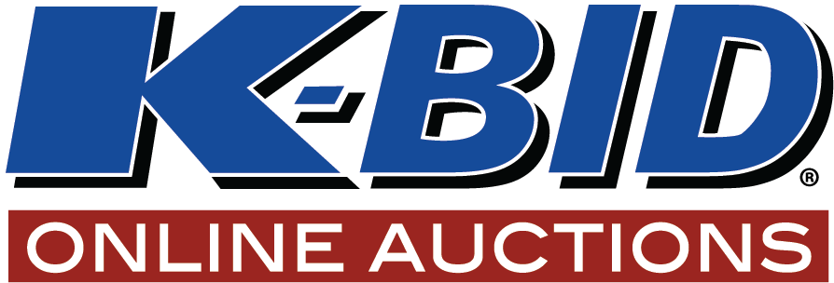

K-BID wants to spotlight you in 2022! Our goal is to promote the independent small businesses that make up the affiliate network and put faces and names to the people behind the auctions. To do so we need some information from you!

Please provide the following
Affiliate Name:
Owner’s (or person(s) being spotlighted) Name:
Location:
Affiliate Start Date:
Types of auctions you specialize in:
Please provide a quick elevator pitch of your company, what type of clients do you assist, what are your specialties, information about the services you provide?
Personal Questions
What drove you to becoming an affiliate of K-BID?
What do you like most about the auction business?
What previous business experience do you have that translated well into the auction business?
Interesting information about you?
Tell us about your family if they are involved?
What are your passions/hobbies outside of work?
Any fun or interesting auction stories to share?
If there is any other information that you think might be appropriate for an affiliate spotlight blog post, please include it! These are meant to be fun, while also showing off your skills and services to potential buyers and sellers. We will use these on our website and on social media as free advertising.
Please include a picture to use of you, your staff, your location, whatever you think would work best for this spotlight. Once received, we will write up the affiliate spotlight and send it over to you for approval prior to posting.
Send the completed form to affiliateservices@k-bidmail.com to get started!

